## Steps to Download and Install Eclipse IDE

**Step  1)** Go to [**http://www.eclipse.org/downloads/packages/**](http://www.eclipse.org/downloads/packages/)

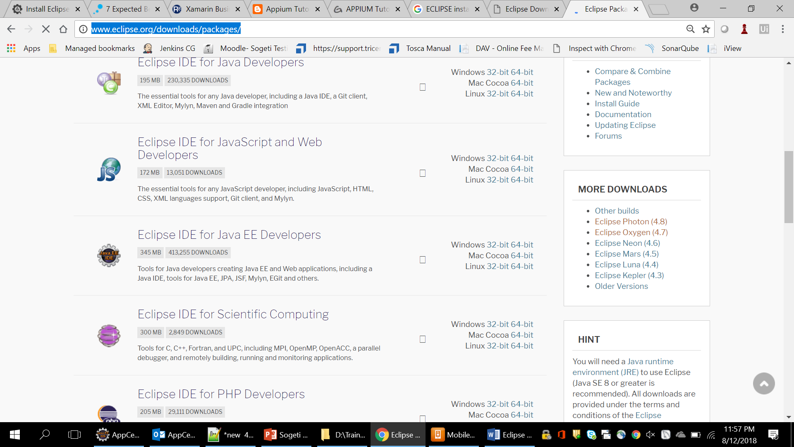

**Step 2)** Select Windows 64 and if you have a **32 bit** Windows, select Windows 32 bit.

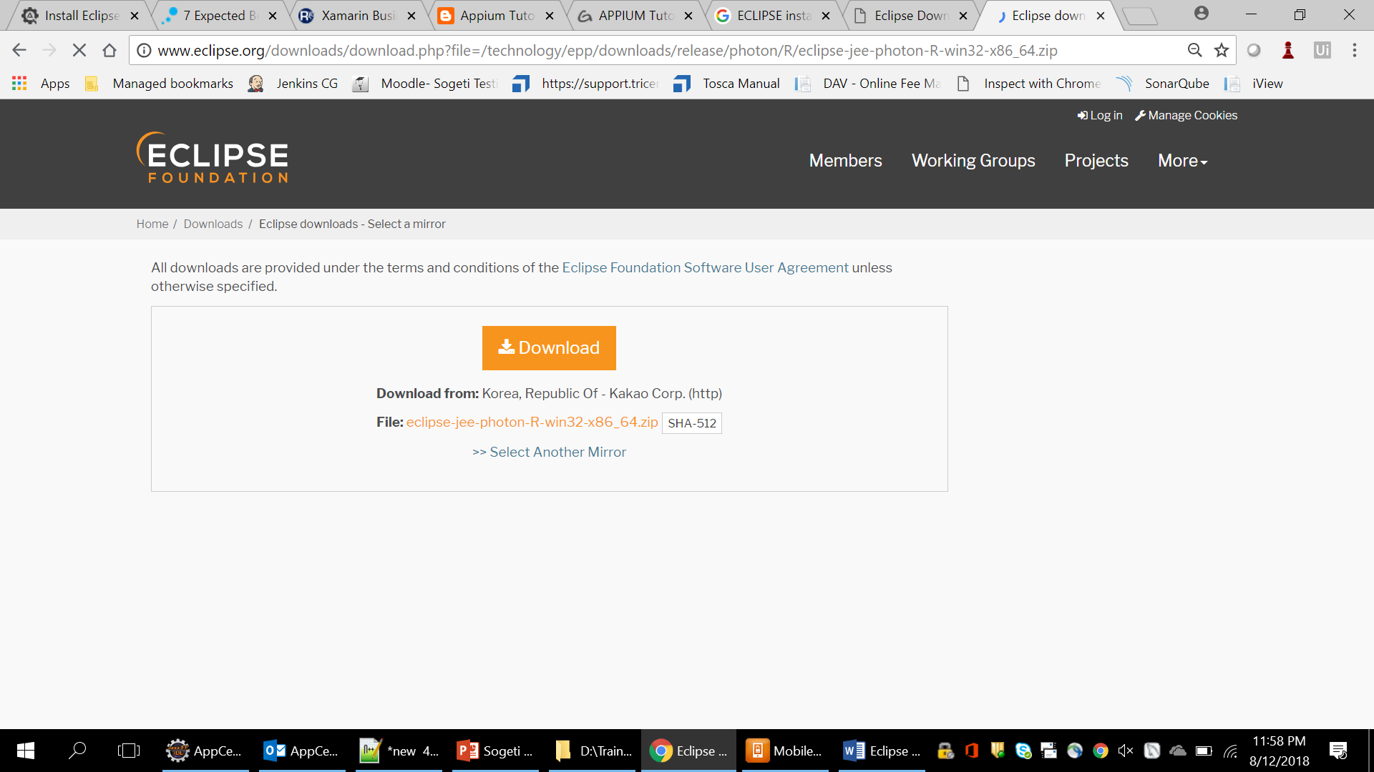

**Step 3) Download** the .zip file to your disk.

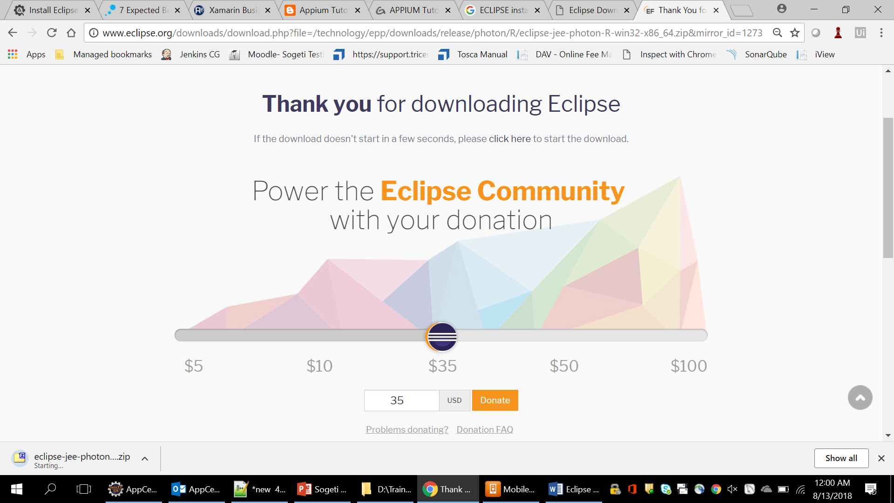

**Step 4)** Once you have downloaded the Eclipse archive you will need to **Extract**the zip file.

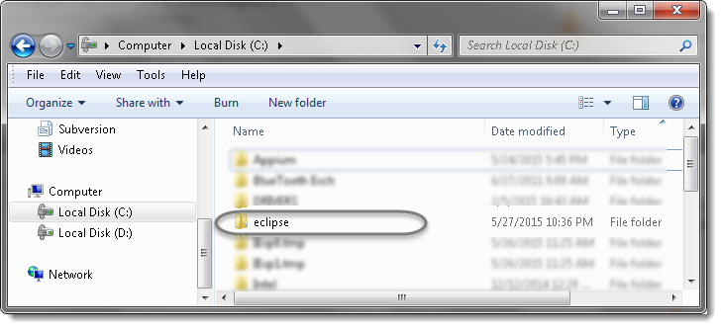

**Step 5)** Since Eclipse IDE does not have any installer, there will be a file inside the Eclipse folder named **eclipse.exe**. You can **double click**on the file to run Eclipse**.**

